# Catalogue API Document

Table of Contents

Catalogue API Document 1

Overview 1

API Flow 1

Sample codes 2

Positive responses 4

Negative responses 6

API docs 7

Unit tests 7

## Overview

This document highlights API implementation of Books catalogue, positive and negative API response, unit tests.

## API Flow

**Spring boot and spring boot starters**

**Client**

**Model**

**Service**

**Controller**

**Repository**

DB

## Sample codes

1. Books Controller

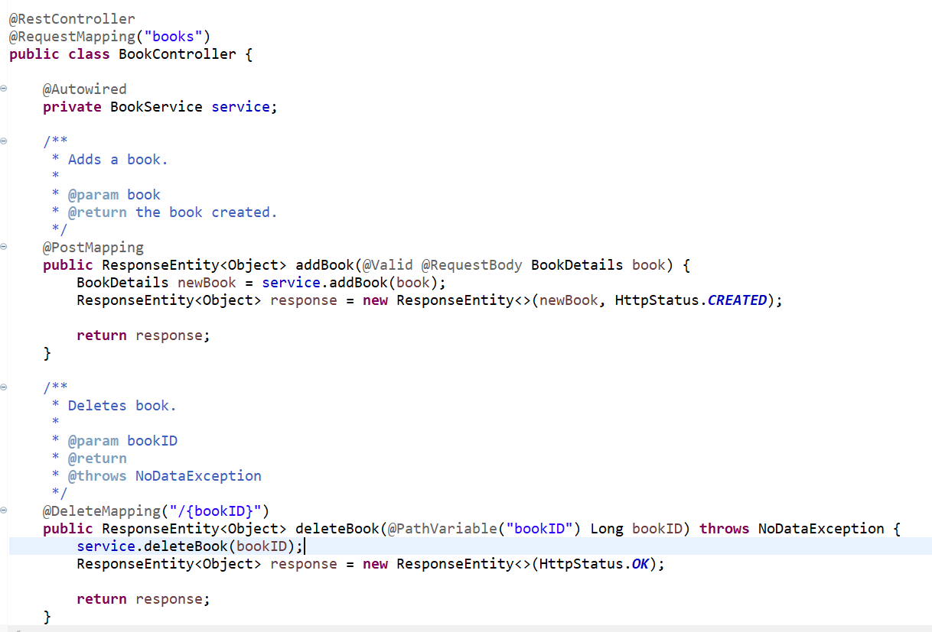

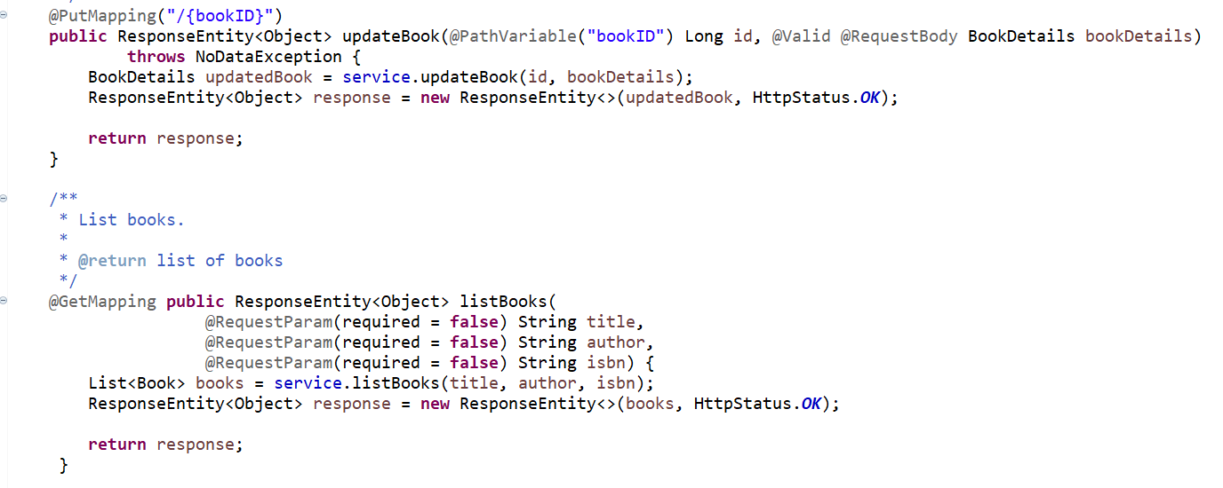

1. Books Service

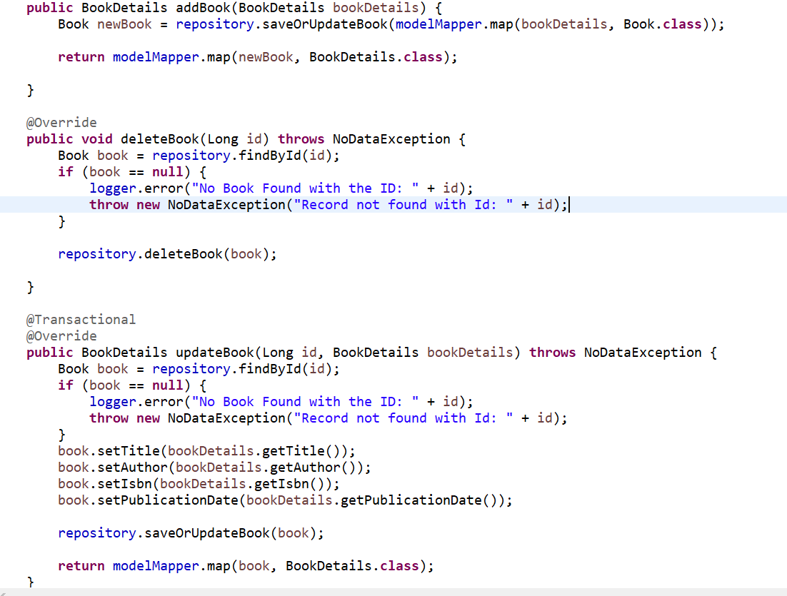

1. Exception Handler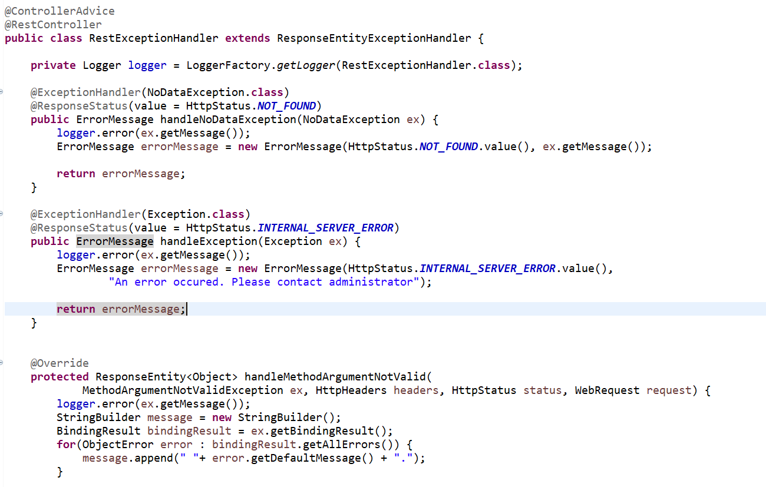

## Positive responses

1. Add a book.

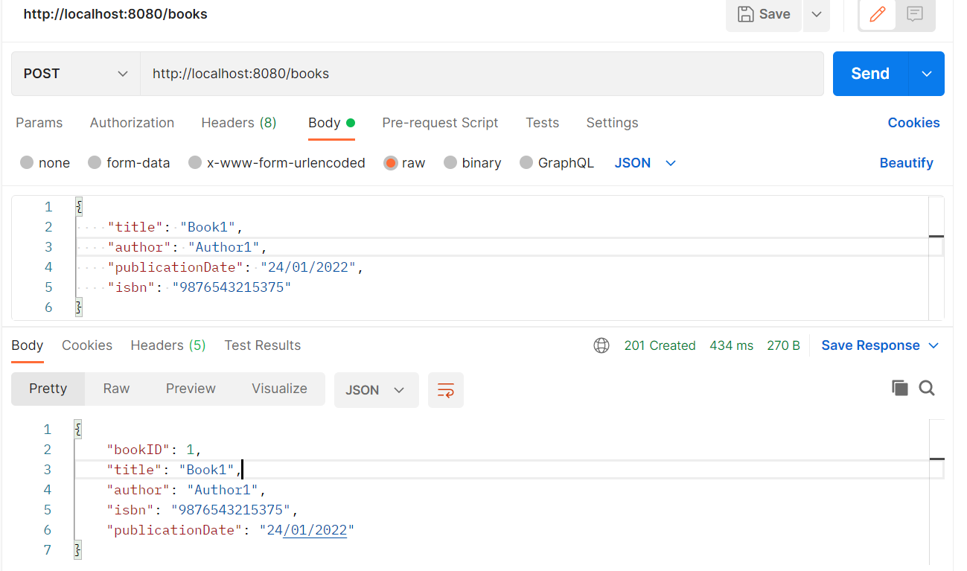

1. Update the book.

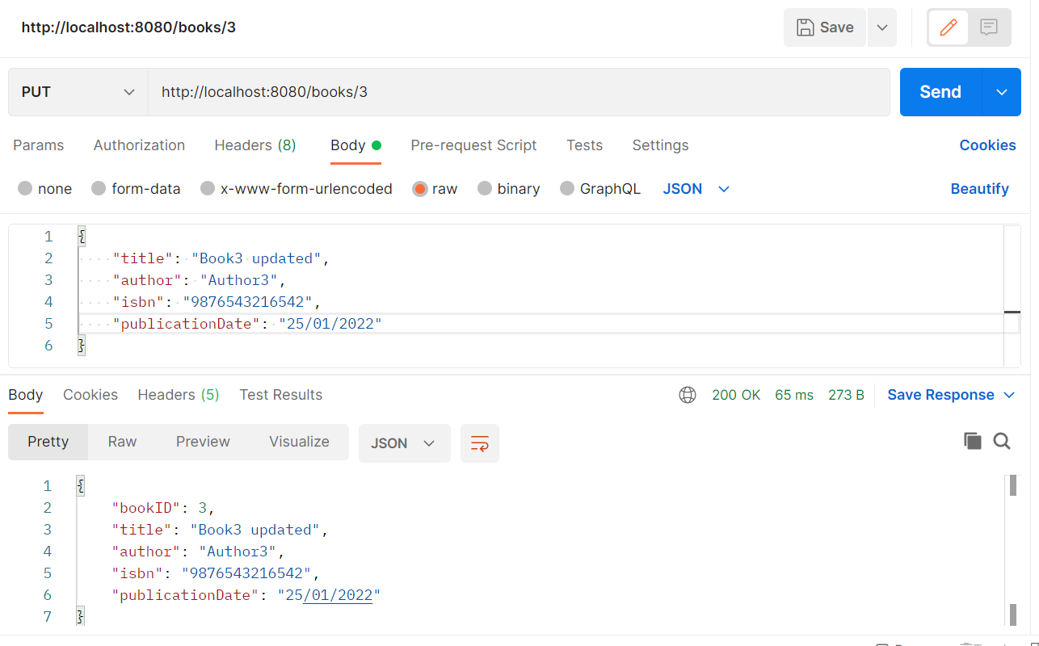

1. Delete the book.

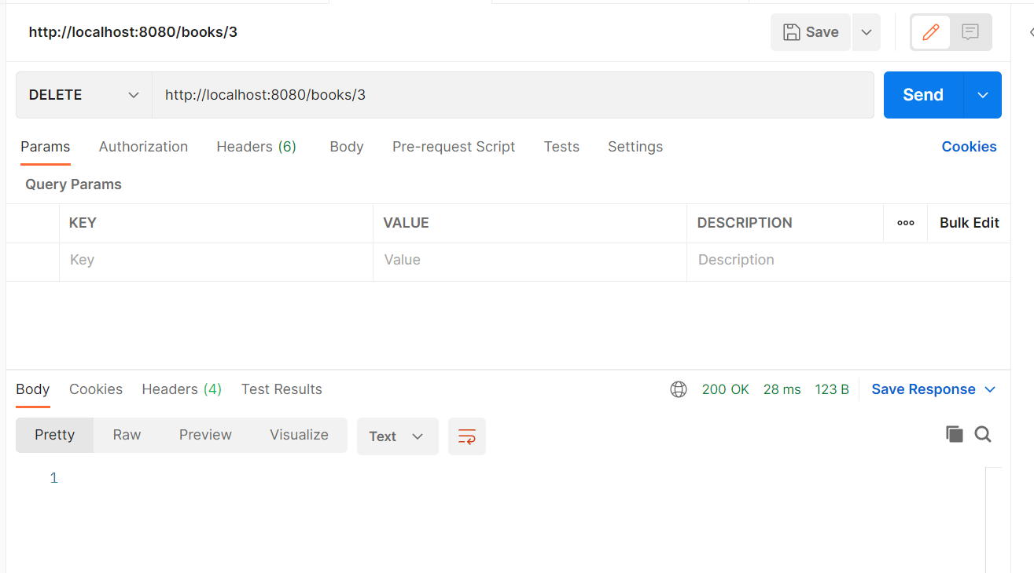

1. List books based on title, author or isbn.

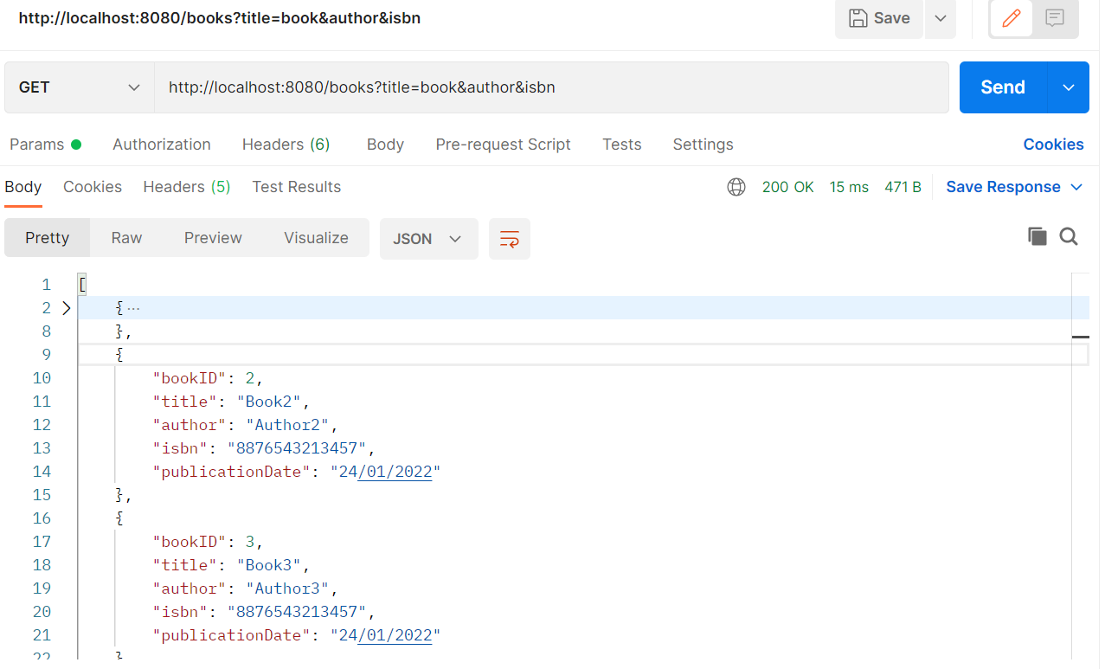

## Negative responses

1. Invalid Input.

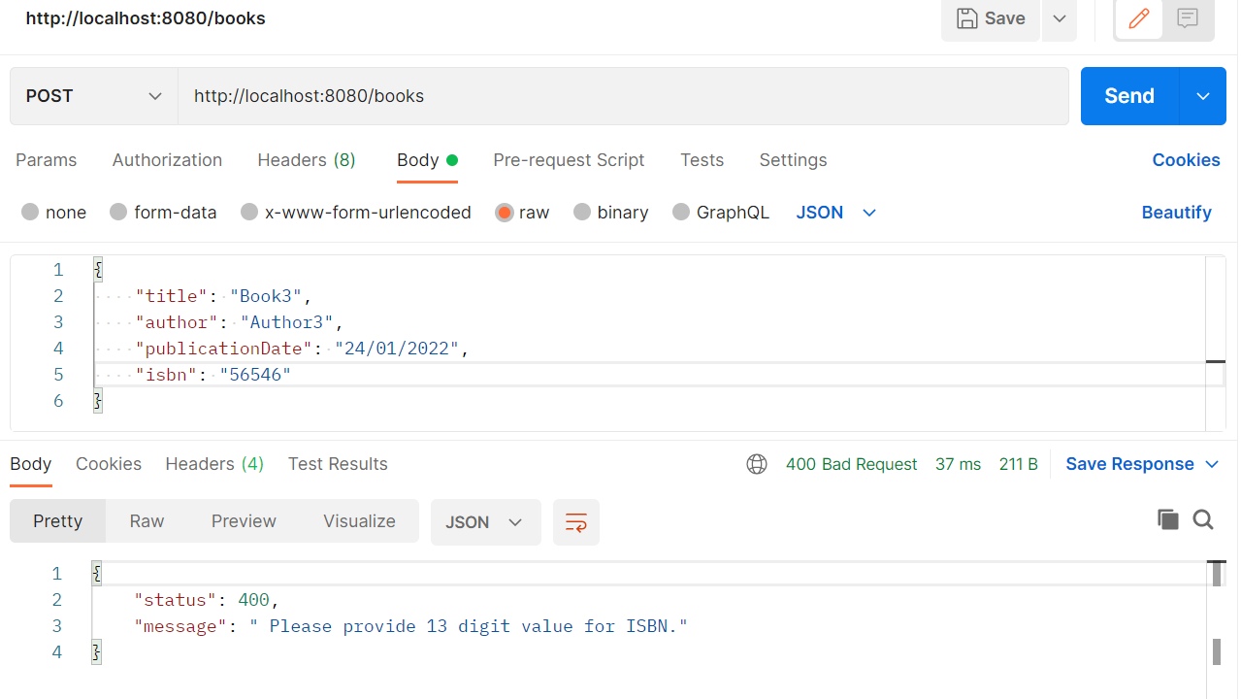

1. No Record found.

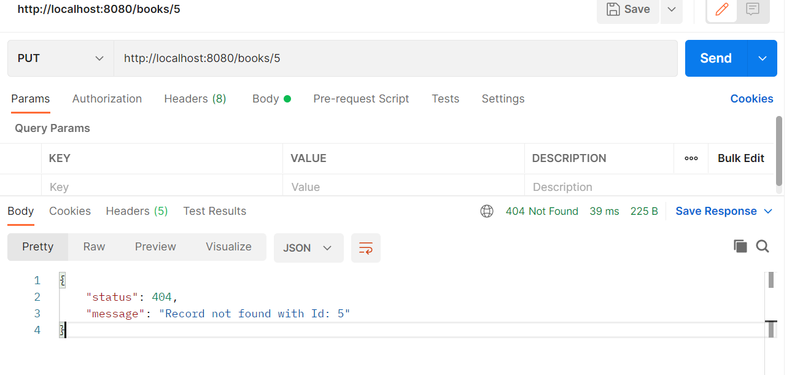

1. Internal error.

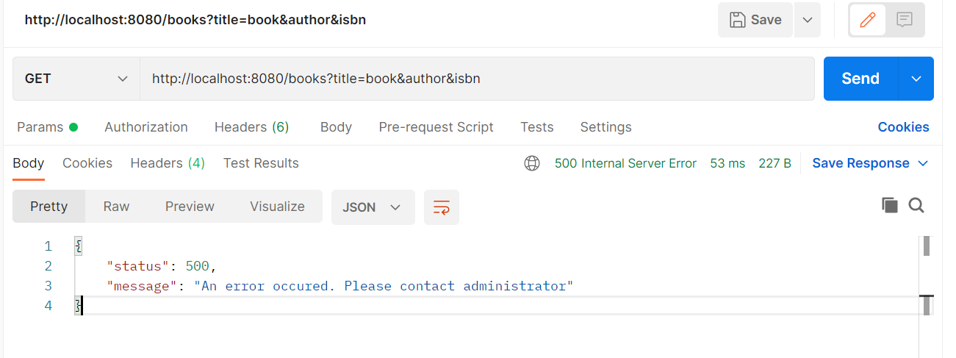

## API docs

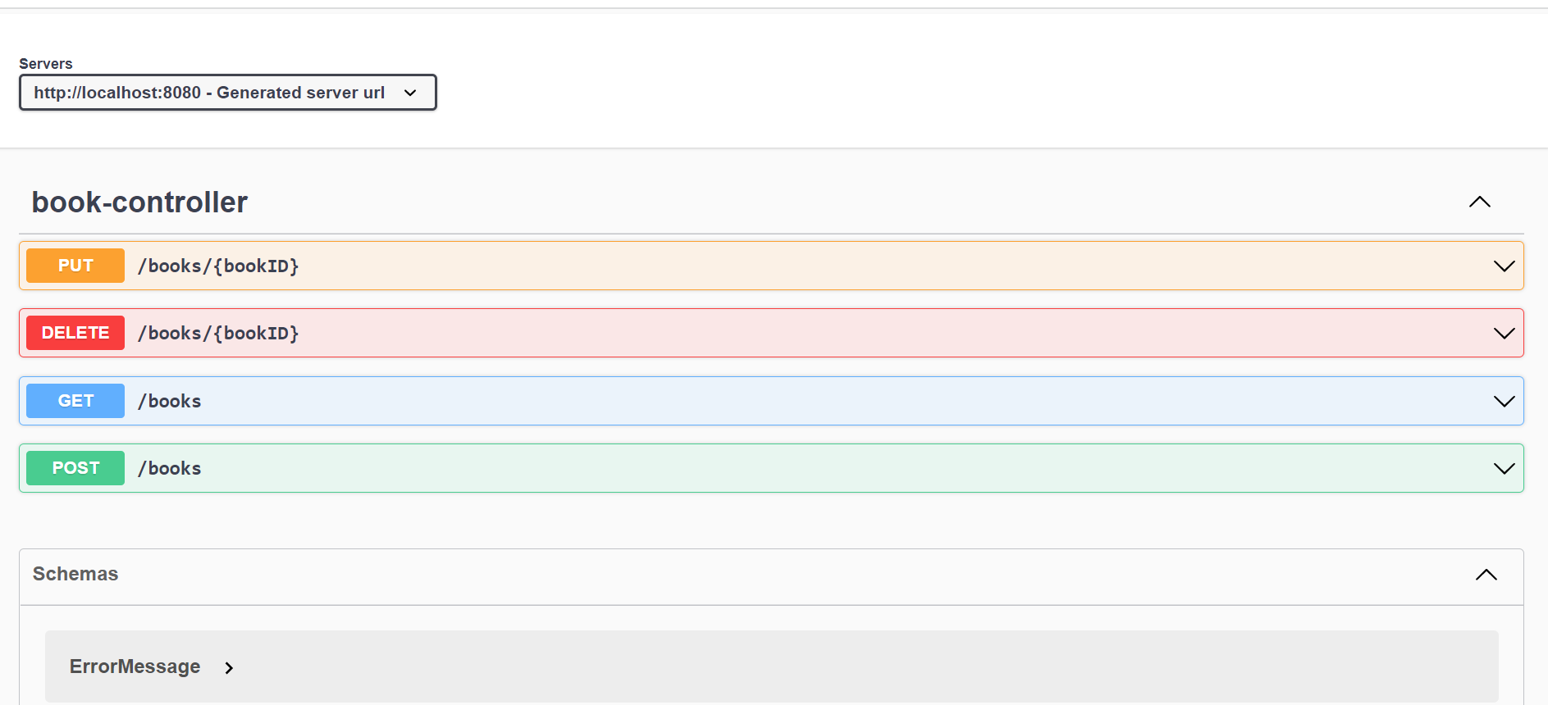

## Unit tests

